PROJECT REPORT

**1. INTRODUCTION**

*1.1 OVERVIEW*

In today's competitive job market, job seekers often apply to multiple jobs and struggle to keep track of their applications. This is where a job application tracking system can come in handy. A job application tracking system is a customer relationship management (CRM) tool that helps job seekers keep track of the jobs they have applied to and the status of each application. It can also help recruiters by sorting through applications, matching candidates to open positions, and providing analytics to help them make more informed hiring decisions.

The job application tracking system is designed to be user-friendly, with a clean and intuitive interface that is easy to navigate. Job seekers can create an account and add information such as their resume, cover letter, and job preferences. They can then search for jobs using various criteria, such as job title, location, and company. Once they find a job they are interested in, they can apply directly through the system and track the status of their application. This allows job seekers to stay organized and informed, making the job search process less stressful.

For recruiters, the job application tracking system can help streamline the hiring process. They can create job postings and receive applications directly through the system, which can be automatically sorted and ranked based on various criteria, such as education and experience. The system can also use machine learning algorithms to match candidates to open positions, making it easier for recruiters to find qualified candidates. Additionally, the system can provide analytics on the hiring process, such as the number of applicants for each job posting and the time it takes to fill open positions.

There are several benefits to using a job application tracking system. For job seekers, it can reduce the time and effort required to keep track of job applications, allowing them to focus on finding the right job. For recruiters, it can help save time and resources by automating tasks such as sorting through applications and matching candidates to open positions. Additionally, the system can provide valuable insights into the hiring process, allowing recruiters to make more informed decisions.

Overall, the job application tracking system is a useful tool for both job seekers and recruiters. By providing a centralized platform for job applications and hiring management, it can make the job search and hiring process more efficient and less stressful. As the job market continues to evolve and become more competitive, the job application tracking system will likely become an increasingly important tool for job seekers and recruiters alike.

*1.2 Purpose*

The purpose of building a job application tracking system CRM is to provide job seekers and recruiters with an efficient and effective tool to manage the job application and hiring process. In today's fast-paced and competitive job market, it can be challenging for job seekers to keep track of the many job applications they submit, and for recruiters to sort through the overwhelming number of applications they receive. A job application tracking system can help to alleviate these challenges and streamline the process for both job seekers and recruiters.

For job seekers, the purpose of the job application tracking system is to provide an organized and centralized platform to manage job applications. The system allows job seekers to easily apply to multiple jobs and track the status of their applications in one place. They can upload their resume, cover letter, and other application materials, and receive updates on their application status. This can help job seekers to stay organized, focused, and motivated in their job search.

For recruiters, the purpose of the job application tracking system is to improve the efficiency and effectiveness of the hiring process. The system allows recruiters to manage job postings, receive applications, and sort through them based on various criteria. It can also provide valuable analytics and insights into the hiring process, such as the number of applications received, the time to fill positions, and the quality of applicants. This can help recruiters to make more informed hiring decisions and ultimately hire the best candidate for the job.

In summary, the purpose of building a job application tracking system CRM is to provide an efficient and effective tool for job seekers and recruiters to manage the job application and hiring process. It can help job seekers to stay organized and motivated in their job search, while providing recruiters with valuable insights and analytics to make more informed hiring decisions. Ultimately, a job application tracking system can help to improve the overall efficiency and effectiveness of the hiring process, which can benefit both job seekers and employers.

**2. Problem definition and design thinking**

*2.1 Empathy map*

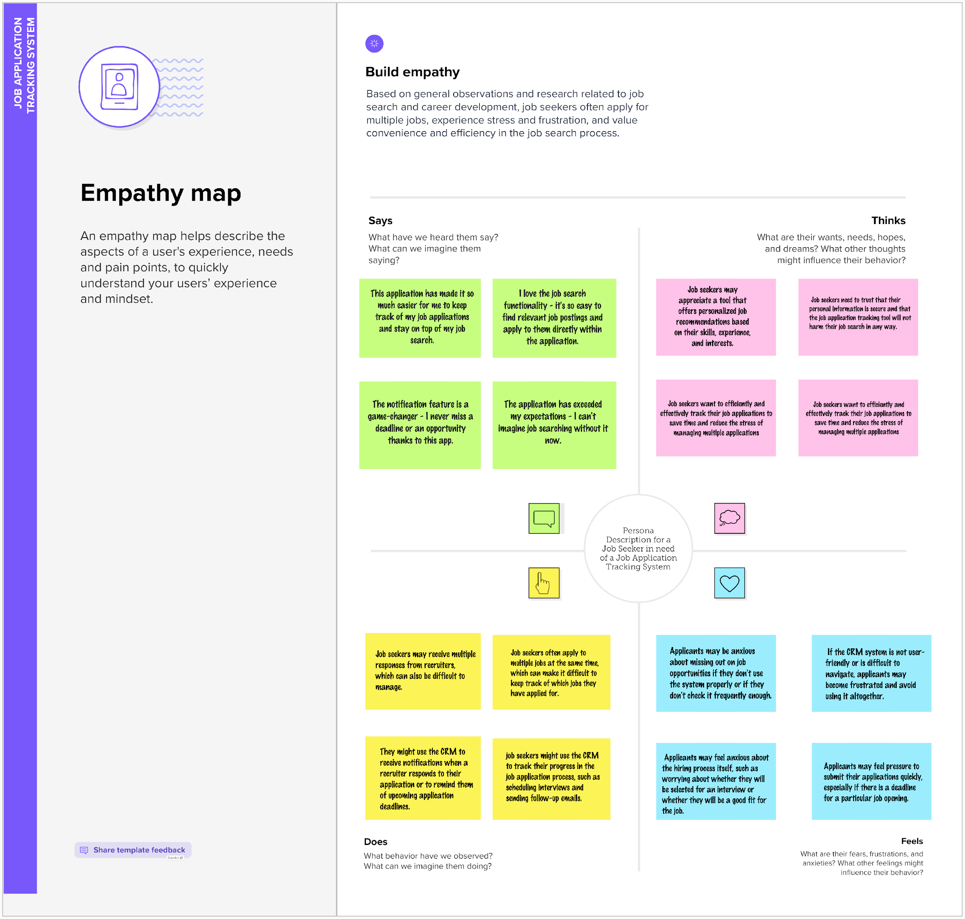

*2.2 Ideation & Brainstroming Map*

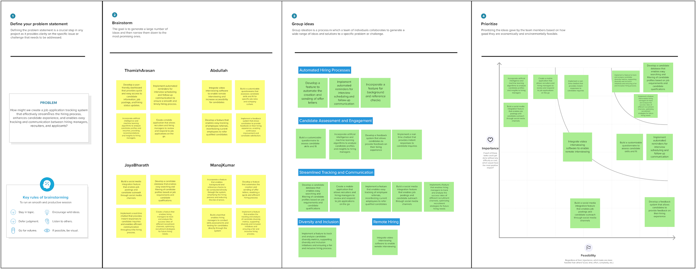

**3 RESULT**

*3.1 Data Model:*

| Recruiter | | Field label | Data type | | --- | --- | | Recruiter | Text(255) | | Recruiter NUmber | Auto Number | | Created By | Lookup(User) | | Candidate | Master-Detail(Candidate) | |
| --- | --- | --- | --- | --- | --- | --- | --- | --- | --- | --- | --- |
| Job | | Field label | Data type | | --- | --- | | Job Number | Auto Number | | Created by | Lookup(user) | | Email | Email | | Last Modified by | Lookup(user) | | Owner | Lookup(User,Group) | |
| Candidate | | Field label | Data type | | --- | --- | | Candidate Number | Auto Number | | Created by | Lookup(user) | | Email | Email | | Last Modified by | Lookup(user) | | Owner | Lookup(User,Group) | |
| Job Application Object | | Field Label | Data type | | --- | --- | | Job application Object Number | Auto Number | | Created by | Lookup(user) | | Email | Email | | Last Modified by | Lookup(user) | | Owner | Lookup(User,group) | |

| Tab | | Field label | Data type | | --- | --- | | Tab Number | Auto Number | | Created by | Lookup(user) | | Email | Email | | Last Modified by | Lookup(user) | | Owner | Lookup(User,group) | |
| --- | --- | --- | --- | --- | --- | --- | --- | --- | --- | --- | --- | --- | --- |

*3.2 Activity & Screenshot*

**Recuriter**

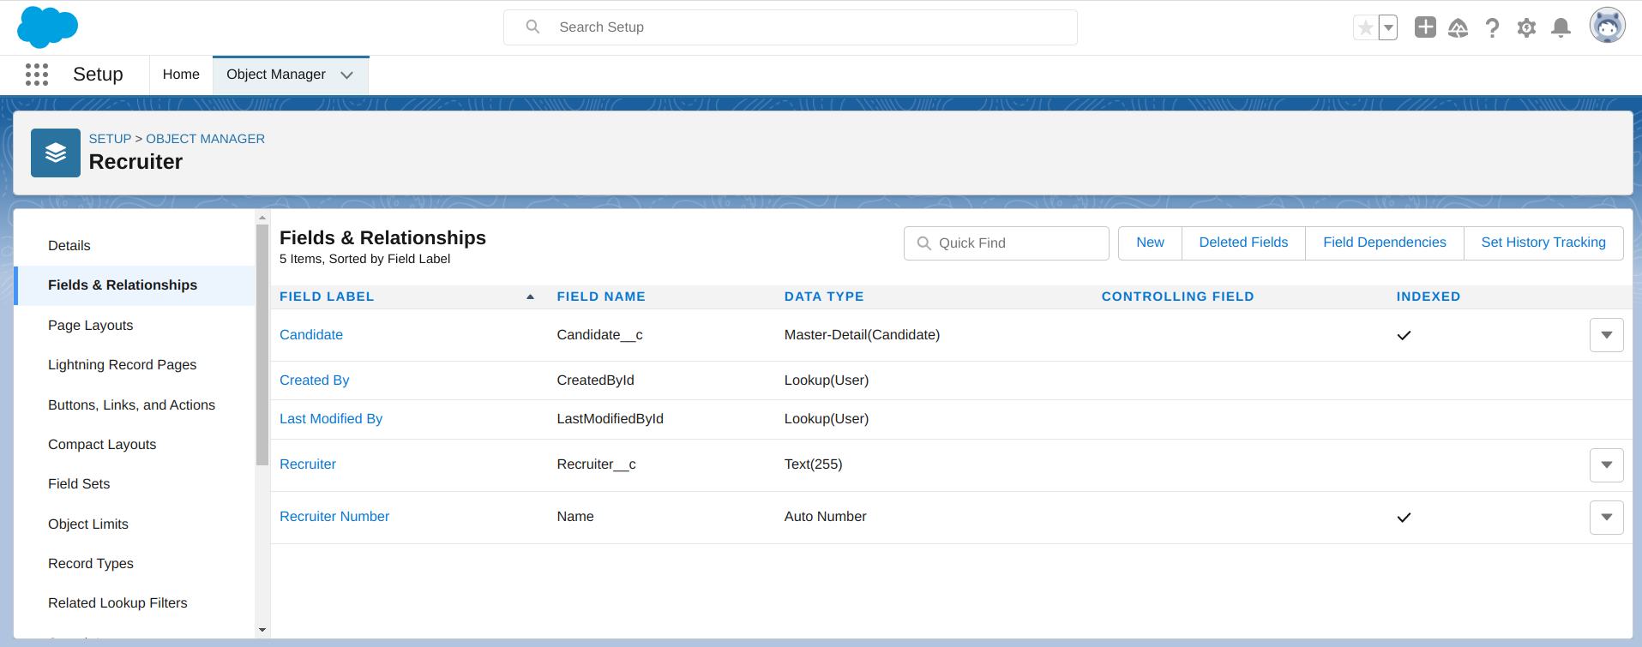

**Job**

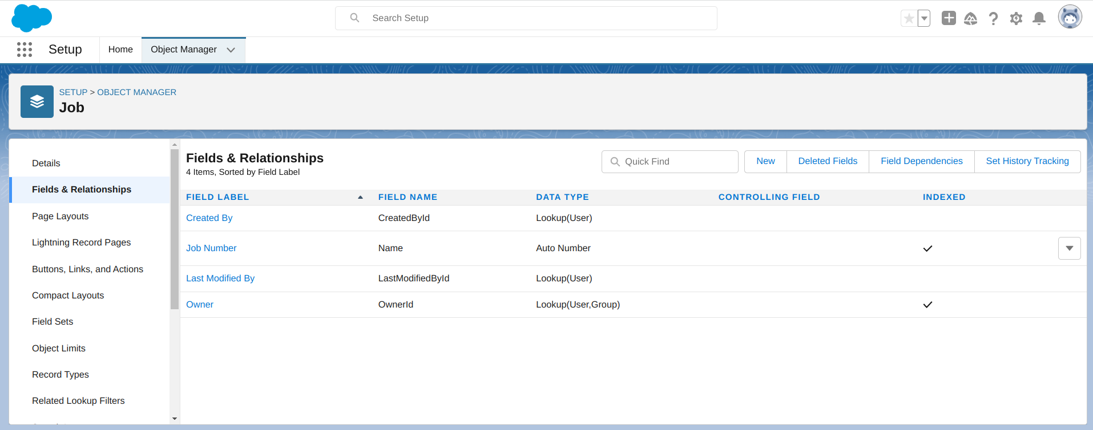

**Candidate**

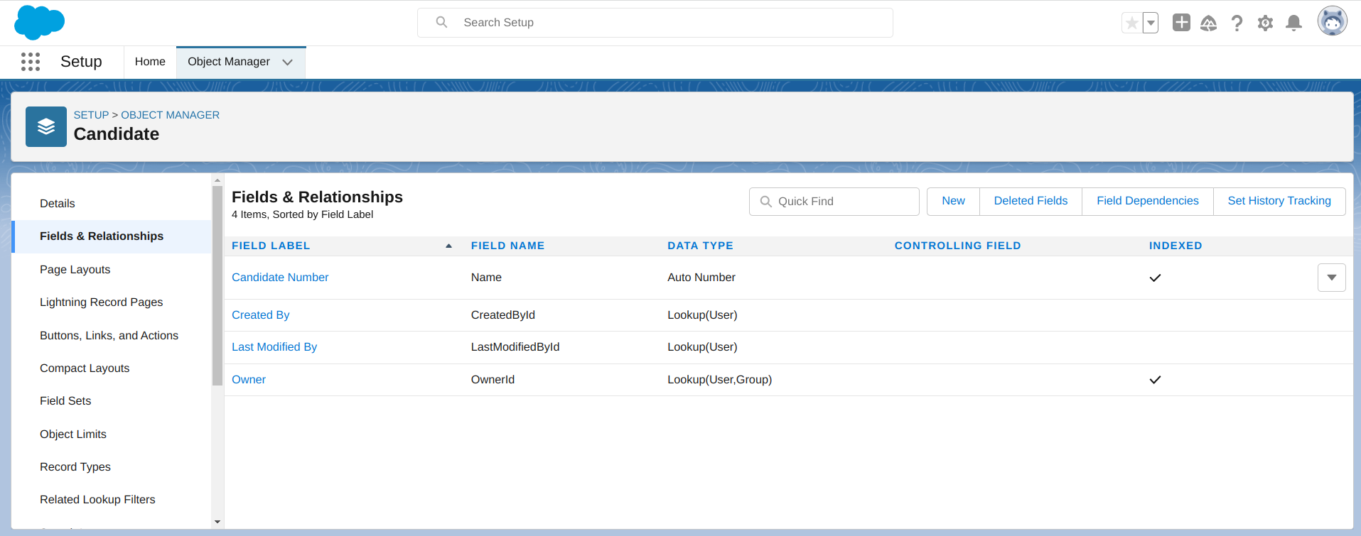

**Job Application object**

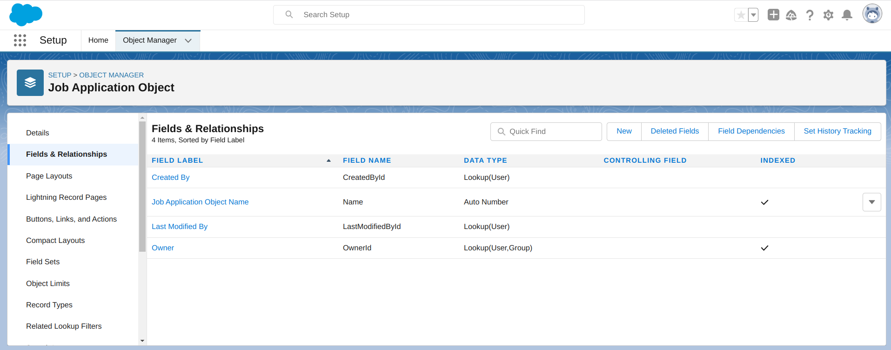

**Tab**

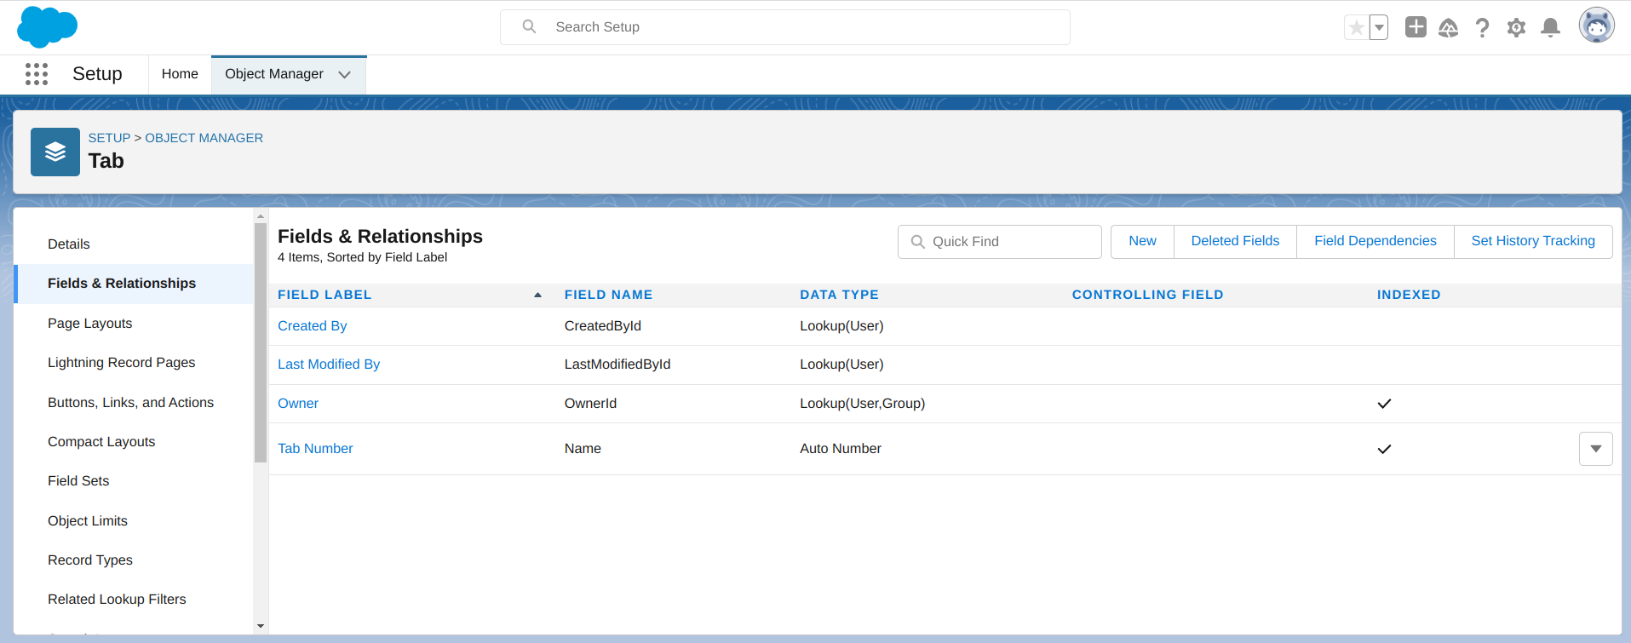

**Profile**

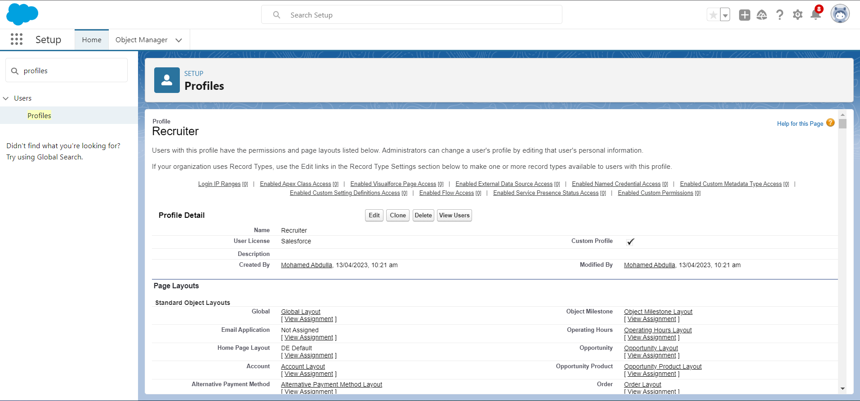

A profile is a group/collection of settings and permissions that define what a user can do in salesforce

**User**

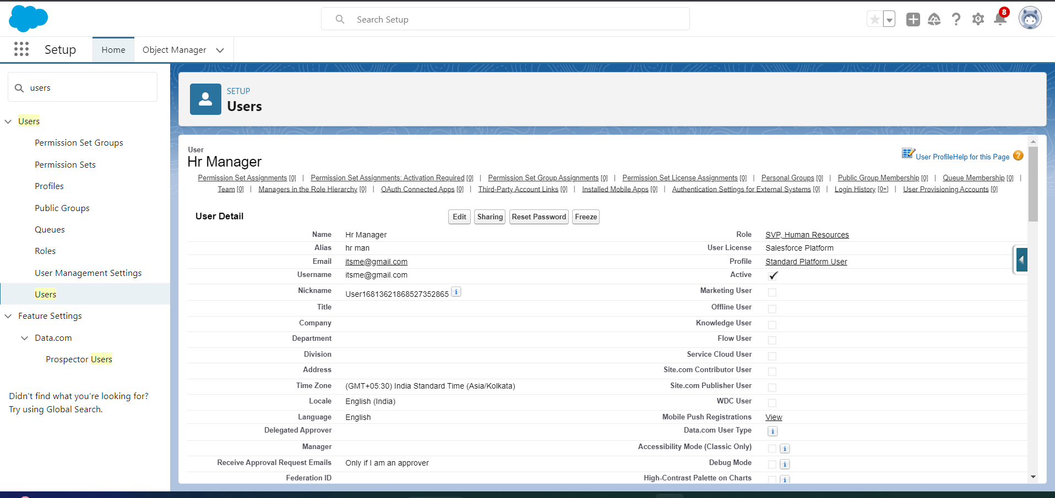

A user is anyone who logs in to Salesforce. Users are employees at your company, such as sales reps, managers, and IT specialists, who need access to the company's records.

**Sharing settings**

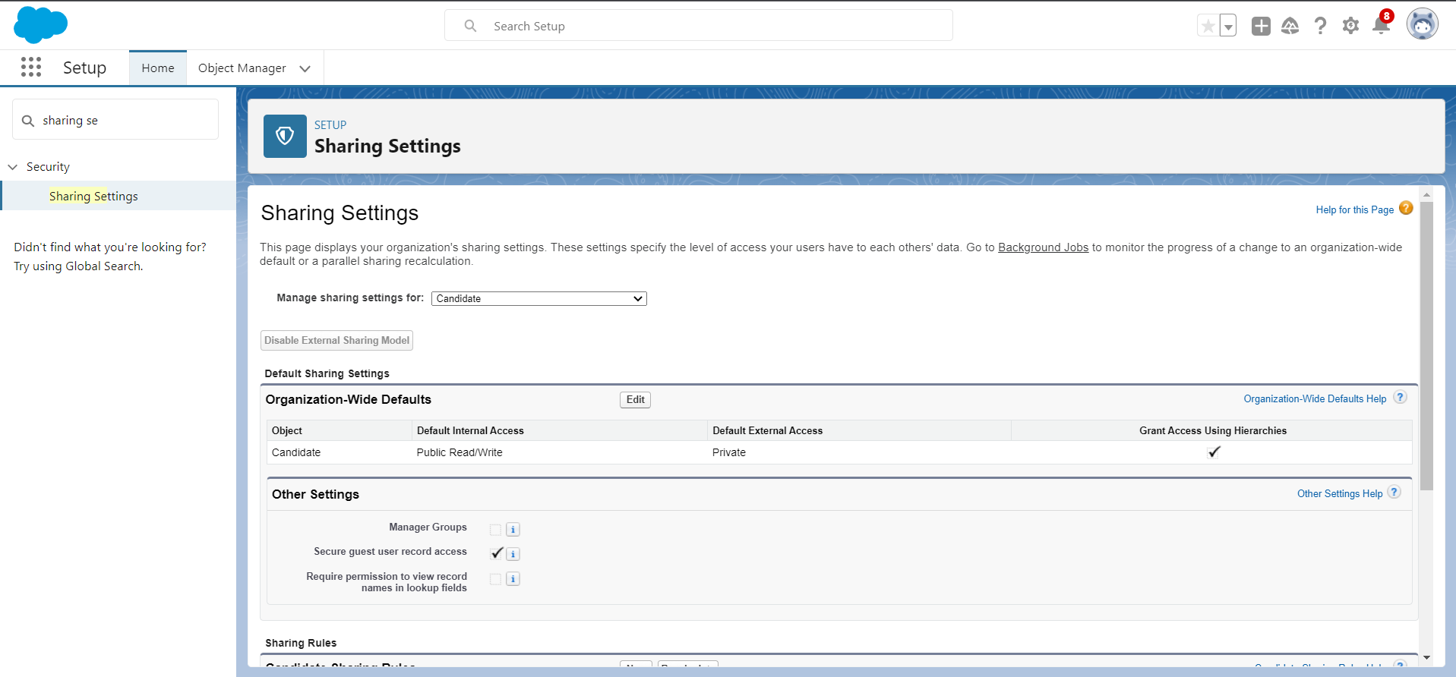

Sharing rules help users to share records based on conditions. It is basically created for objects whose organization-wide defaults (OWD) are set to public read-only or private because sharing rules can only extend the access and not restrict it.

**Reports:**

**jobs**

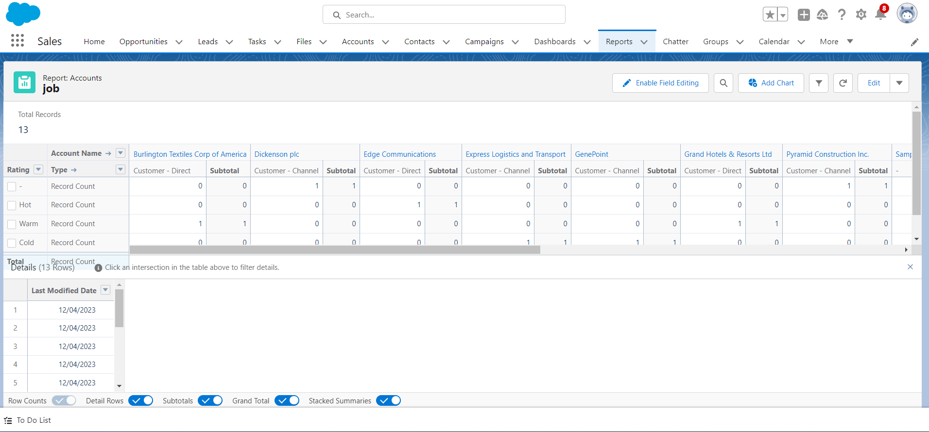

**Candidates**

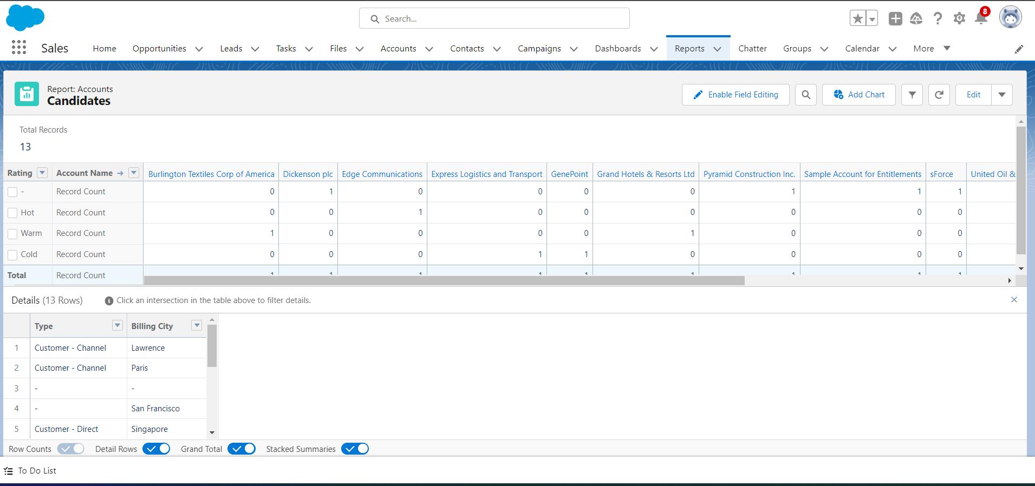

**Job Application**

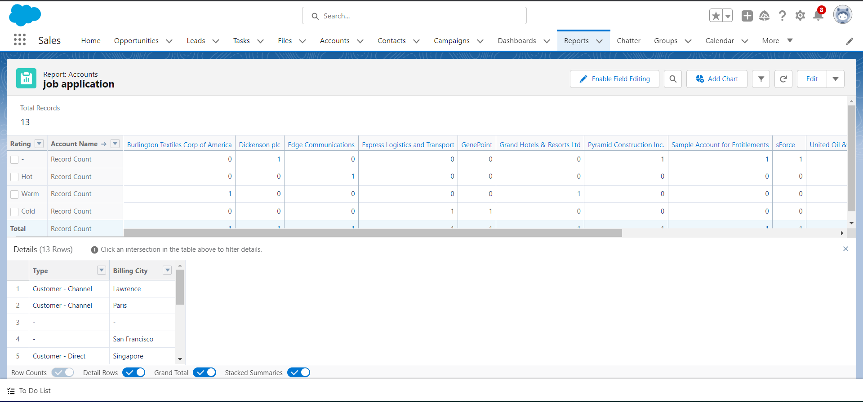

A report is a list of records that meet the criteria you define. It's displayed in rows and columns, and can be filtered, grouped, or displayed in a graphical chart. Every report is stored in a folder. Folders can be public, hidden, or shared, and can be set to read-only or read/write.

Trailhead Profile Public URL

##### Team Lead – https://trailblazer.me/id/thamizhar

##### Team Member 1- https://trailblazer.me/id/mabdullah95

##### Team Member 2 - https://trailblazer.me/id/jayaj34

##### Team Member 3 - https://trailblazer.me/id/mkumar2903

# Project Respect Template

###### ADVANTAGES & DISADVANTAGES

# ADVANTAGES

1. Streamlines the hiring process: A job application tracking system CRM can help to streamline the hiring process by providing a centralized platform to manage job postings, receive applications, and sort through them based on various criteria.

2. increases efficiency: The system can help to improve the efficiency of the hiring process by automating certain tasks, such as sending out rejection emails or scheduling interviews.

3. Reduces biases: A job application tracking system can help to reduce biases in the hiring process by using objective criteria to sort and rank applicants.

4. Improves communication: The system can provide improved communication between job seekers and recruiters, keeping both parties updated on the status of the application process.

5.Provides valuable insights: A job application tracking system can provide recruiters with valuable analytics and insights into the hiring process, such as the number of applications received, the time to fill positions, and the quality of applicants.

# DISADVANTAGES

1.Cost: Implementing a job application tracking system CRM can be costly for small businesses or startups.

2. Time-consuming to set up: It can take time and effort to set up and customize the system to fit the needs of the company.

3. Over-reliance on technology: Relying too heavily on the job application tracking system can lead to a lack of personalization in the hiring process, which can ultimately negatively impact the candidate experience.

4. Limited functionality: Some job application tracking systems may have limited functionality or may not integrate well with other HR software, which can be a limitation for some companies.

5. Potential for technical issues: Like any software, job application tracking systems can experience technical issues, which can disrupt the hiring process and cause delays.

# APPLICATIONS

1. Job postings management: A job application tracking system CRM can help recruiters to manage job postings and easily distribute them across various job boards and social media platforms.

2.Resume screening: The system can quickly screen resumes and identify the most qualified candidates based on certain criteria such as skills, education, experience, and certifications.

3. Candidate communication: The system can provide a centralized platform for recruiters to communicate with job seekers throughout the hiring process, providing updates on the status of their application and scheduling interviews.

4.Applicant tracking: The system can track the status of each applicant throughout the hiring process, providing a complete overview of where each candidate stands and what steps need to be taken next.

5.Interview scheduling: The system can automate the interview scheduling process, allowing recruiters to easily schedule interviews with candidates based on their availability.

6.Data analytics: The system can provide valuable data analytics and insights into the hiring process, allowing recruiters to identify trends and areas for improvement.

7. Compliance management: A job application tracking system can help to ensure compliance with various laws and regulations, such as Equal Employment Opportunity (EEO) guidelines and data privacy laws.

# CONCLUSION

In conclusion, a job application tracking system CRM can be a powerful tool for recruiters to streamline the hiring process and improve communication with job seekers. By providing a centralized platform to manage job postings, receive applications, and track the status of each candidate, recruiters can save time and resources while identifying the most qualified candidates for their open positions.

Additionally, a job application tracking system can help to reduce biases in the hiring process by using objective criteria to sort and rank applicants, ultimately leading to a more diverse and inclusive workforce. The system can also provide valuable data analytics and insights into the hiring process, allowing recruiters to identify trends and areas for improvement.

However, it is important to carefully consider the advantages and disadvantages of implementing a job application tracking system before making a decision. While the system can increase efficiency, reduce biases, and improve communication, it can also be costly, time-consuming to set up, and over-reliant on technology.

Ultimately, a job application tracking system CRM can be a valuable asset for any company looking to improve their hiring process and find the best candidates for their open positions. By weighing the pros and cons and selecting a system that fits the unique needs of their organization, recruiters can harness the power of technology to make informed and efficient hiring decisions.

# FUTURE SCOPE

* The future scope of a job application tracking system CRM is vast and promising. As technology continues to advance and the job market becomes increasingly competitive, companies will need to leverage every advantage they can to attract and retain the best talent.
* One potential area of future development for job application tracking systems is the integration of artificial intelligence (AI) and machine learning (ML) algorithms. These technologies could be used to automate the screening process even further, identifying top candidates based on a wider range of criteria, such as personality traits and soft skills.
* Another area of potential development is the use of blockchain technology to secure and verify candidate data, making the hiring process more transparent and trustworthy. This could help to reduce concerns around data privacy and security, which have become increasingly important in recent years.
* Additionally, the use of virtual reality (VR) and augmented reality (AR) could revolutionize the hiring process, allowing job seekers to participate in immersive virtual interviews and assessments from anywhere in the world. This could greatly expand the talent pool and make it easier for companies to find the best candidates for their open positions.
* Overall, the future scope of a job application tracking system CRM is vast and exciting. With continued advancements in technology and a growing need for streamlined and efficient hiring processes, job application tracking systems are sure to play an increasingly important role in the job market of the future. By staying up-to-date with the latest trends and technologies, companies can leverage these systems to find the best talent and stay ahead of the competition.